Assignment 1 – GitHub Repository Setup Documentation
Name: Raj Rajai
Enrollment Number: 2401031000049
Course: Web Technology with UI/UX
Semester: 4th

1. Introduction
This document describes the step-by-step process of creating a GitHub repository, organizing assignment folders, and uploading files as per the given instructions.

Step 1: Creating a GitHub Account
Open https://github.com
Click on Sign Up
Enter required details and create an account
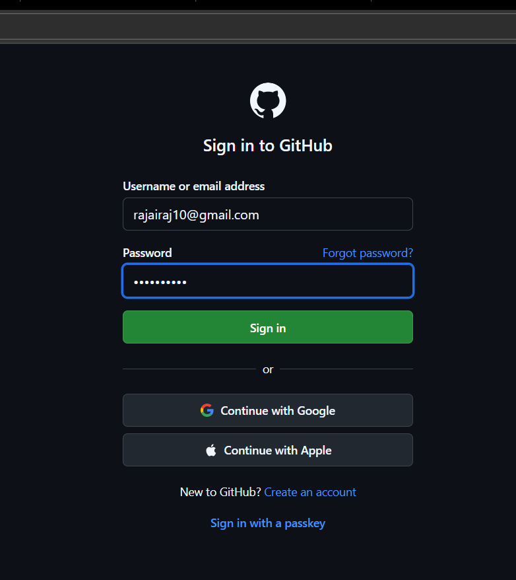

Step 2: Creating a New Repository
Click on “New Repository”
Enter repository name as Enrollment Number
Select visibility Public
Click on Create Repository
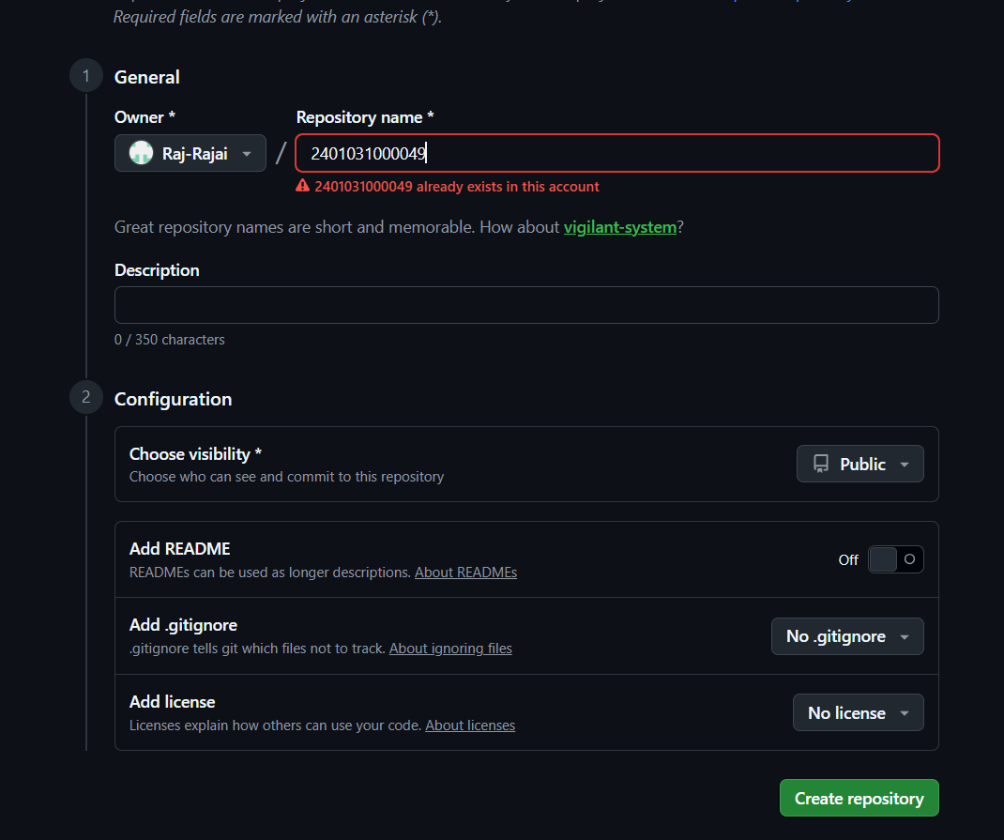

Step 3: Uploading Files
Click on Add Files
Upload this Word document into Assignment_1 folder
Upload UI design images into Assignment_1
Drag and Drop folders of Assignement 1 & 2
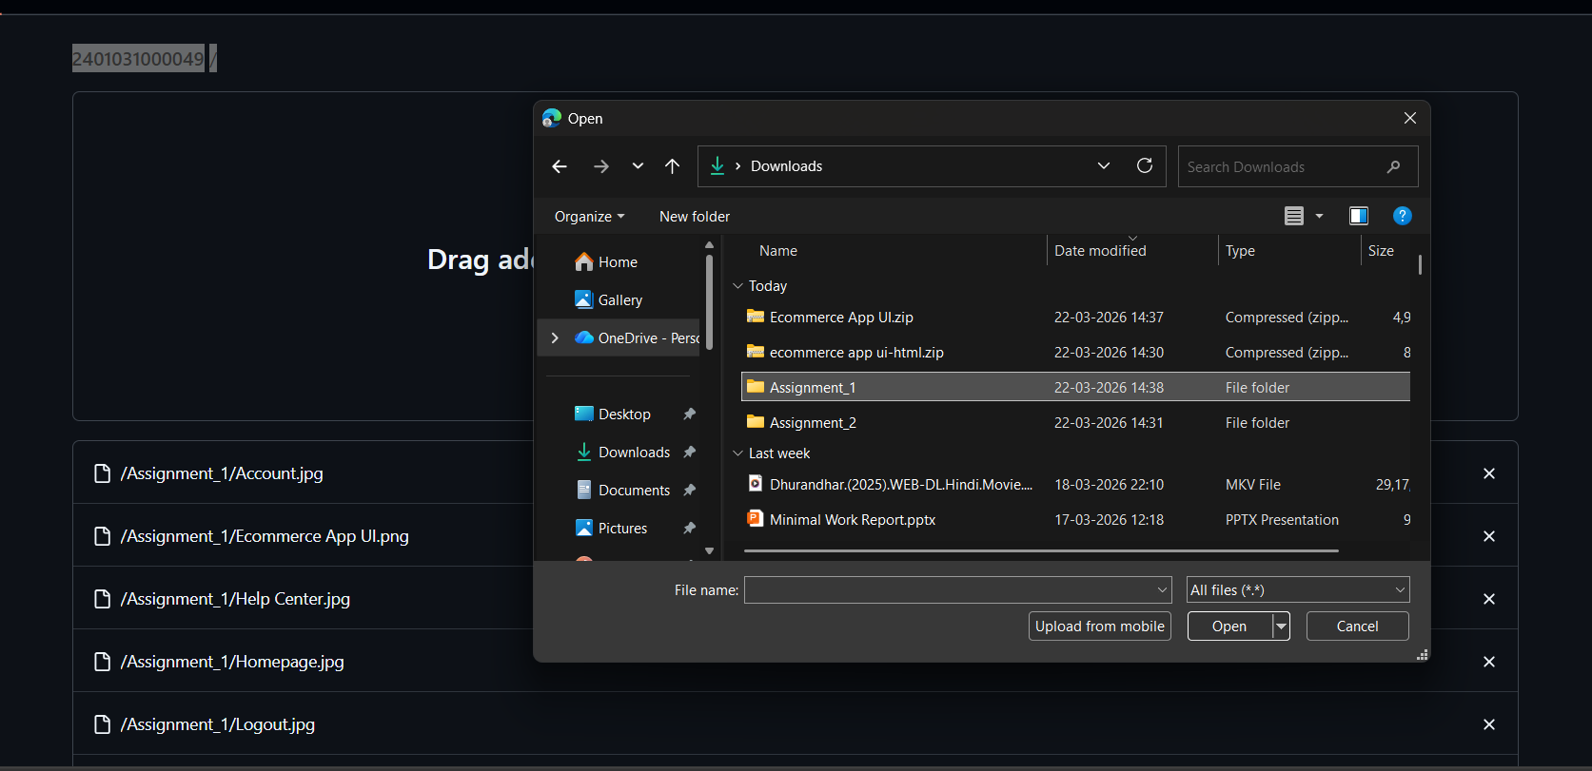
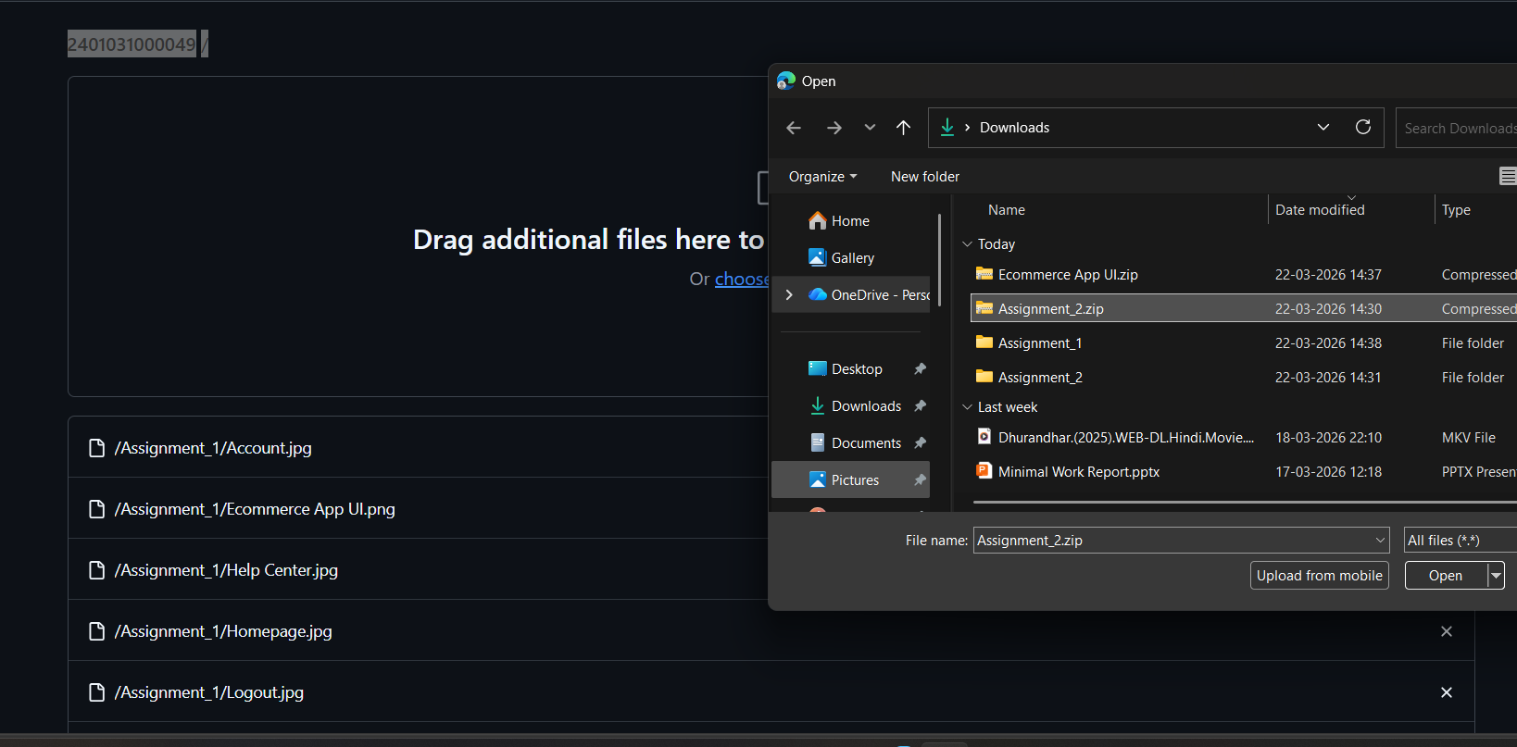

Step 5: Final Repository Structure
The repository contains:
Assignment_1 (Documentation + UI Screens)
Assignment_2 (For future HTML/CSS code)
